MegaMek Invitational

Official Map Pack

Rules & Planetary Conditions

# Map 1 – 20x20 – Marik – Factory

## Background:

The Factory is House Marik’s sponsored arena on Solaris. An indoor arena, it is tightly packed and deadly.

With a combination of raised areas, fuel tanks ready to blow, and piles of rubble, there are plenty of opportunities for ‘mechs to gain an advantage or the element of surprise over their opponents.

Savvy mechwarriors will know to watch their step here – the slick pavement of the Factory is guaranteed to cause some slips and falls.

## Map Image:

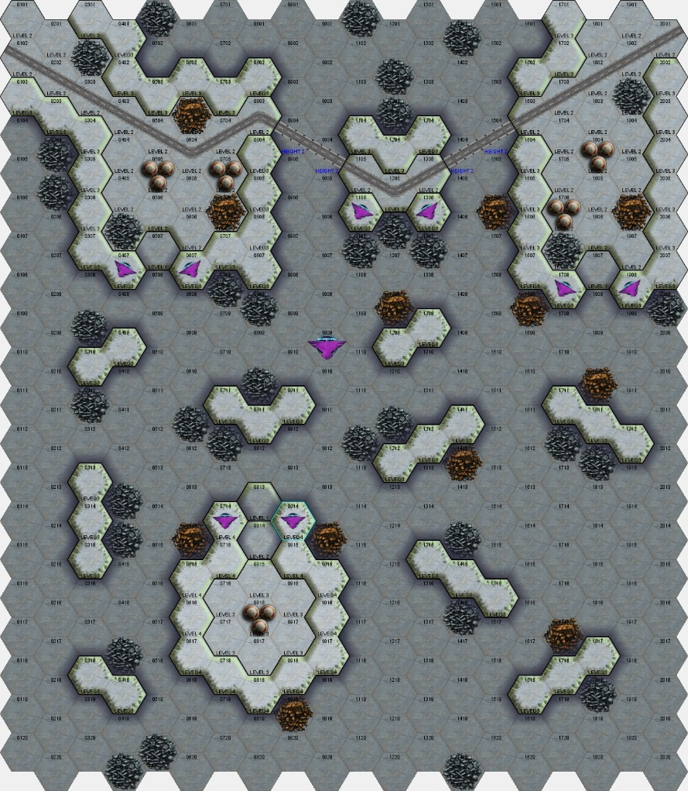

## ‘Planetary Conditions’ to use:

All planetary conditions should be left as the MegaMek defaults.

No wind settings should be used.

## Starting Locations:

Players may start on any board edge.

## Special Rules:

Fuel tanks may be targeted, with explosive results.

# Map 2 – 25x25 – Independent – Mesa Madness

## Background:

Mesa Madness is a new independent arena, established in the decade since the Clan Invasion. Carved into the terrain, it is designed to simulate the harsh canyons and quicksand of desert worlds throughout the Inner Sphere.

The arena is heavily temperature controlled to ensure that heat is a concern for even the coolest running custom designs, and sandstorms can be simulated to add another layer of difficulty for the competitors.

## Map Image:

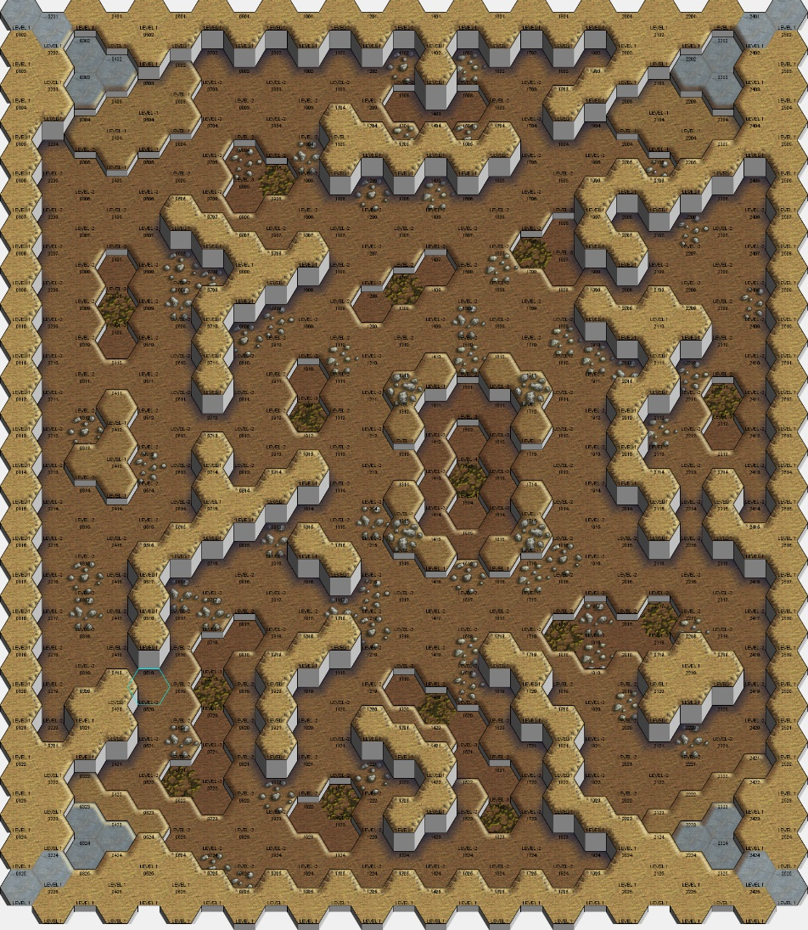

## ‘Planetary Conditions’ to use:

Temperature: 45*C

Blowing sand may be used. To randomise this, if all players agree, roll 2d6. On an 8+, blowing sand is in play.

## Starting Locations:

Players must start on one of the four pavement areas in the corners of the map. They must not share a starting position with a hostile ‘mech.

## Special Rules:

Players may not fire their weapons at another ‘mech until they reach the valley floor. ‘Mechs may jump onto the mesas in the canyon and fire down on other ‘mechs.

‘Mechs may not use the edge of the arena. All combat must take place in the canyon.

# Map 3 – 30x20 – Davion – Boreal Reach

## Background:

Boreal Reach is a popular and famous arena on Solaris, used for everything from light and medium matches up to the assault circuit. Sponsor by the Davions and incorporating LosTech in its design, the Reach is typically used to represent an arctic environment or mountain ranges. The frigid temperatures allow energy builds to thrive whilst ice underfoot means mechwarriors must watch their step.

Whilst the LosTech terrain and holo tools can be used to simulate any environment, the arena is best known for its arctic arrangement, and is used in this format for the MegaMek Invitational.

## Map Image:

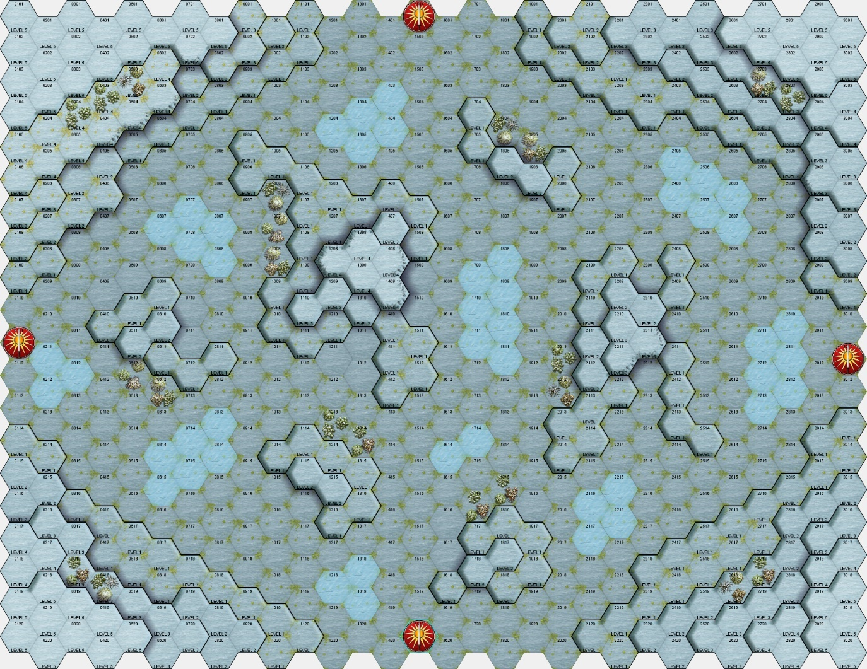

## ‘Planetary Conditions’ to use:

Temperature: -50*C

Snowfall may be used to add a complicating factor. Roll a 2d6. On a 7+, light snowfall covers the arena. On a 10+, heavy snowfall is used.

## Starting Locations:

Players may start on any of the Davion icons in the North, East, South, or West.

Hostile ‘mechs may not share a starting location.

## Special Rules:

If a mechwarrior is forced to eject, special rescue drones are dispatched to prevent long-term cold injury. Any mechwarrior recorded as ‘Killed by extreme temperature’ is not treated as killed in the post-match phase.

# Map 4 – 30x20 – Liao – Jungle

## Background:

The Jungle is a lush arena, located in the Cathay district of Solaris. Modelled to resemble the tropical rainforest of Spica, it is a favourite of mechwarriors and fans alike for the close fighting it creates. Sprinklers installed in the roof may be used to simulate everything from drizzle to heavy tropical storms.

The Capellan Confederation pumps money into the Jungle as a key point of national pride in having a presence on the games world. If needed, the configuration can be changed between seasons or even between matches to keep competitors on their toes.

## Map Image:

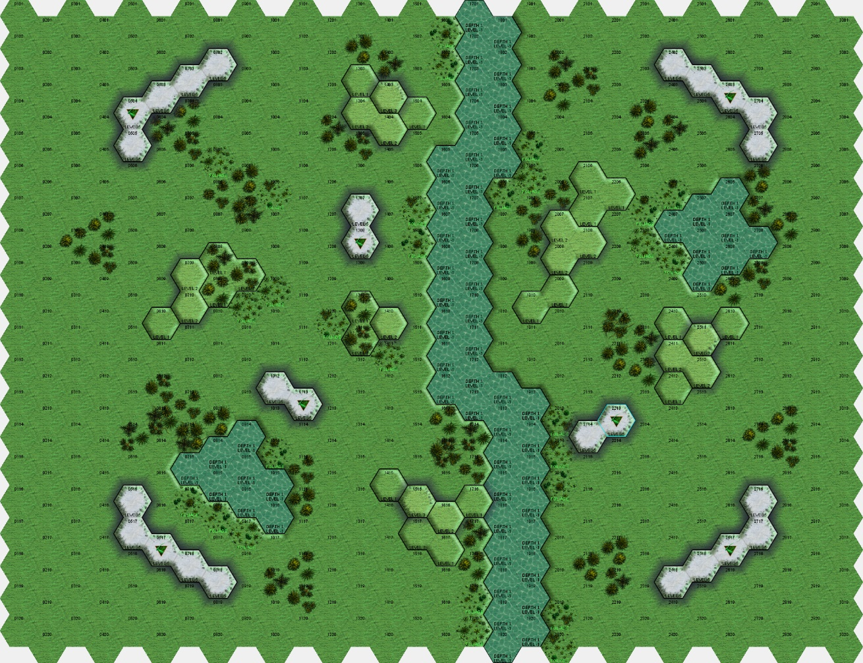

## ‘Planetary Conditions’ to use:

Temperature: 38*C

Rain may be used in the arena to add a complication. Roll a 2d6. On a 7+, light rain is in play, on a 10+, heavy rain is used.

## Starting Locations:

Players may start on any board edge. Players on opposite teams may not share a board edge.

## Special Rules:

None.

# Map 5 – 30x30 – Independent – Island Intercept

## Background:

Modelled on the success of the Liao Jungle, the Island Intercept arena is another new, independently owned arena established since the Clan Invasion. Using the latest technology available, this location simulates a tropical island and is accessed by protected causeways.

Using colossal wind machines installed in the walls of the arena, fight organisers may blast competitors with huge gusts, sending ballistic and missile weapons flying well off-target and forcing a close-in brawl.

## Map Image:

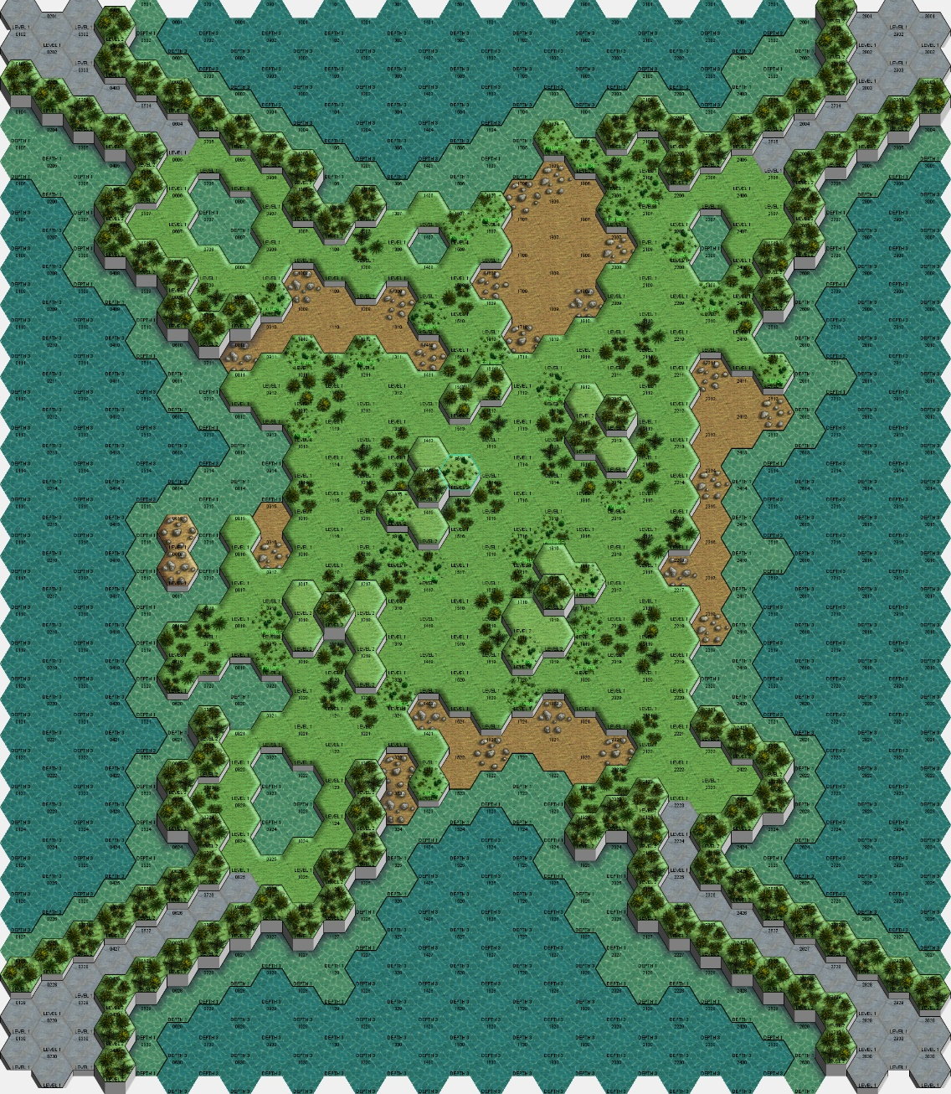

## ‘Planetary Conditions’ to use:

Temperature: 28*C

To simulate choppy seas and storms, wind may be used. Roll a 2d6. On a 7+ a light gale is blowing. On an 11+ a heavy gale is in play.

## Starting Locations:

Players must start on one of the pavement platforms in the corners of the map. Hostile players may not share a starting area.

## Special Rules:

None.

# Map 6 – 40x20 – Steiner – Colosseum

## Background:

The Steiner Colosseum is the premier arena on Solaris; the location where all competitors dream of taking the stage before a live audience of thousands and a broadcast audience of millions, if not billions across the Inner Sphere. The Colosseum is one of the few arenas on Solaris to allow a live audience thanks to its sophisticated disruption field to protect the crowd.

The colosseum provides a relatively flat and open field compared to many arenas on Solaris, and this leads to brutal slugging matches, particularly in the heavier weight classes.

## Map Image:

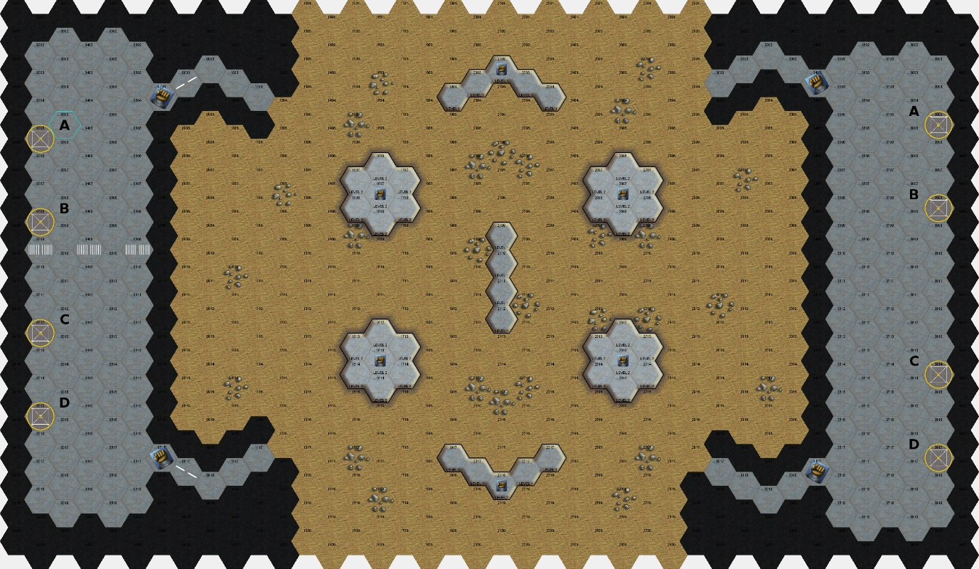

## ‘Planetary Conditions’ to use:

The MegaMek defaults should be used. No weather is in play.

## Starting Locations:

Players may start on the north and south board edges, or may start play in the ‘mech bays in the east and west. Hostile players may not share a ‘mech bay.

## Special Rules:

The impassable hexes around the ‘mech bays do not block line of sight in MegaMek. Players should treat these impassable hexes as line of sight blocking and not fire at opponents through the hexes.

# Map 7 – 30x30 – Independent – Caldera Clash

## Background:

Caldera Clash is a new arena to Solaris, using the latest in post-Clan industrial technology to create an exciting battleground for mechwarriors.

Simulating a volcano, synthetic magma is pumped up through the volcano and out, forming intersecting rivers of magma. These rivers are crossed by bridges, as well as by specially cooled sections of the rivers to allow brave pilots to cross on foot.

The arena offers little cover and is quickly gaining a reputation for spectacular, if exceedingly dangerous, combat.

## Map Image:

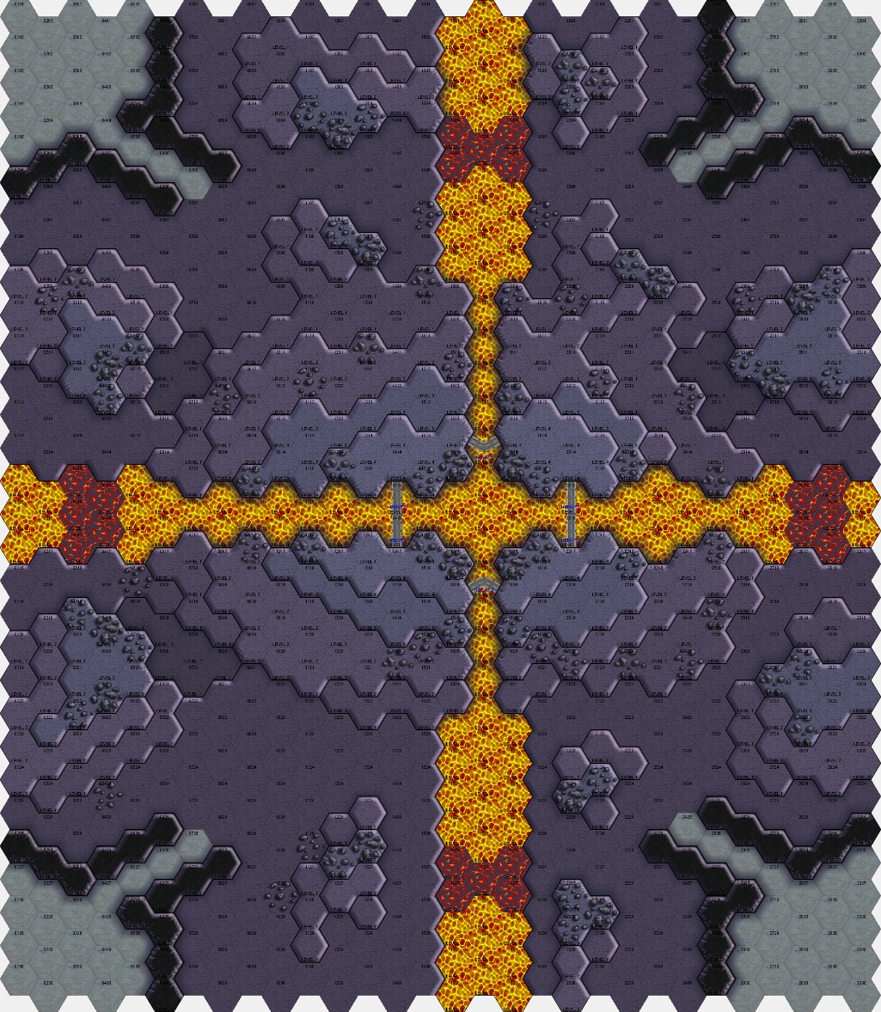

## ‘Planetary Conditions’ to use:

Temperature: 80*C

## Starting Locations:

Players deploy their ‘mechs on the concrete areas in each corner of the map.

## Special Rules:

Rapid rescue: If a mechwarrior is forced to eject, rapid rescue is on hand. If a mechwarrior is forced to eject into magma, or is ‘killed’ by extreme temperatures, they should instead be counted as receiving 5 hits when rolling to see if the pilot is crippled.

# Map 8 – 30x30 – Independent – Urban Combat Zone

## Background:

The urban combat zone is designed to test mechwarriors’ abilities to think under pressure and react to quick target presentation before they slip away into a side street. The arena is constructed in an abandoned property investment area, where lack of funding forced developers to pull out. Rubble and abandoned building sites dot the zone.

The central park provides cover in trees and small ponds, whilst the buildings throughout the zone can have their basements reconfigured by arena technicians using support beams to ensure that no combat is ever the same.

## Map Image:

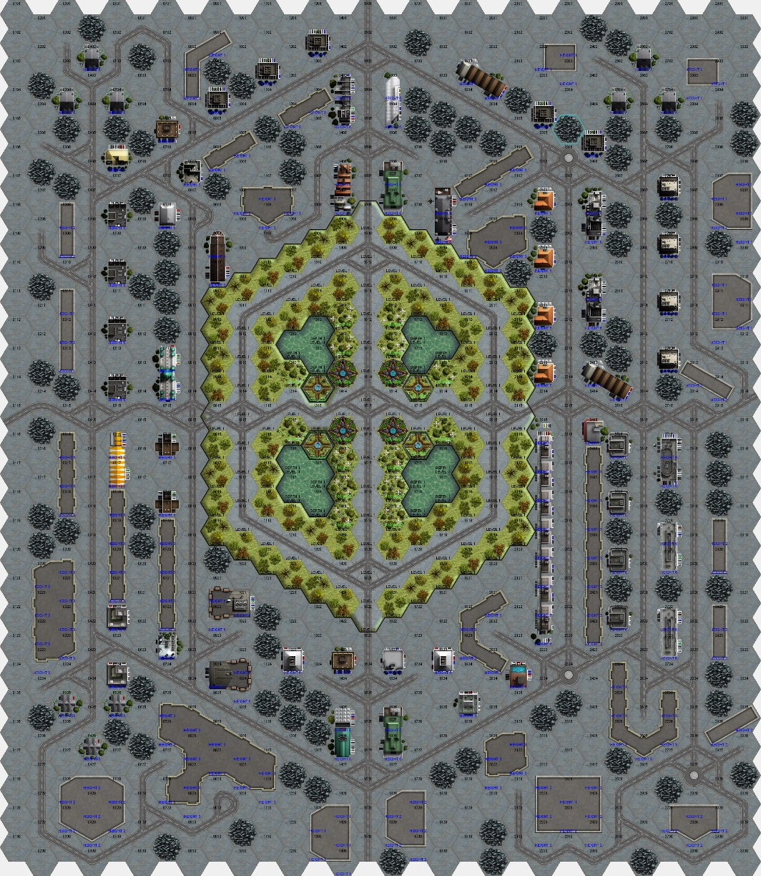

## ‘Planetary Conditions’ to use:

The MegaMek defaults should be used. No weather is in play.

## Starting Locations:

Players should start on one of the four points where roads enter the map in the N, E, S, or W.

## Special Rules:

Double blind: Players may choose to play this map using the double blind rules for a more exciting game.

Both players must agree to play with double blind. This should then be turned on in the MegaMek options in addition to the standard Solaris preset. Inclusive sensor ranges should be used.

# Map 9 – 30x30 – Kurita – Ishiyama Caves

## Background:

The Ishiyama Caves are the Kurita sponsored arena on Solaris VII. Carved into the bedrock, the tight gaps and underground lake are a challenge for many mechwarriors as they try to navigate the rough and rocky ground underfoot.

## Map Image:

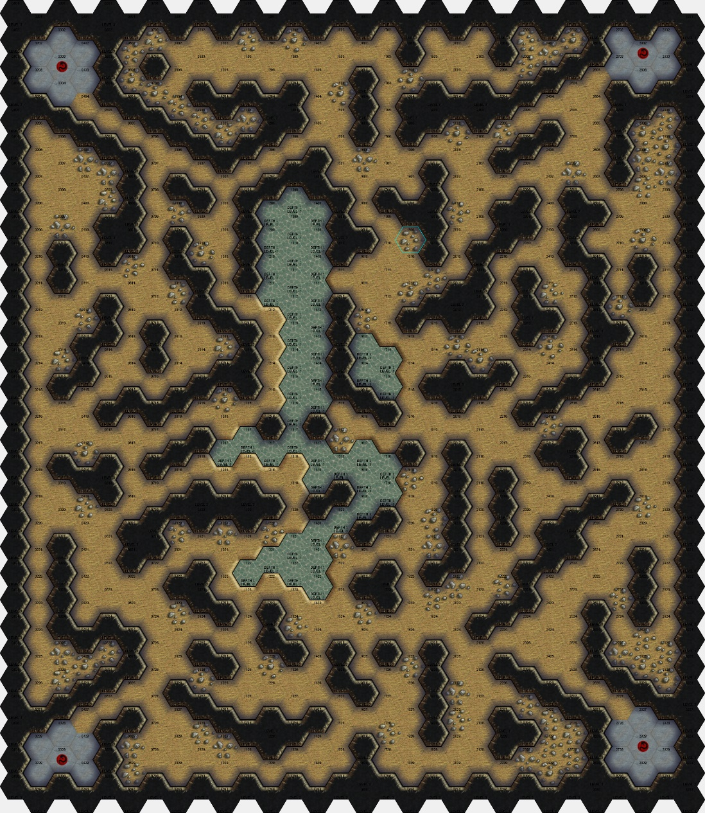

## ‘Planetary Conditions’ to use:

The caves may be filled with light fog from smoke machines to make spotting even more difficult and reduce sight lines.

Roll 2d6. On an 8+, Light Fog is in play.

## Starting Locations:

Players should start on one of the four pavement areas in the corners.

## Special Rules:

Double blind: Players may choose to play this map using the double blind rules for a more exciting game.

Both players must agree to play with double blind. This should then be turned on in the MegaMek options in addition to the standard Solaris preset. Inclusive sensor ranges should be used.

# Map 10 – 30x30 – Independent – Crater Crazy

## Background:

Established on one of the Solaris system’s moons, the Crater Crazy arena is designed to push mechwarriors and their machines to the limits. With no atmosphere and a low G of 0.5, ‘mechs are able to move much more quickly. Pilots must keep their overconfidence in check however, lest they destroy their machine before they even contact their opponent.

## Map Image:

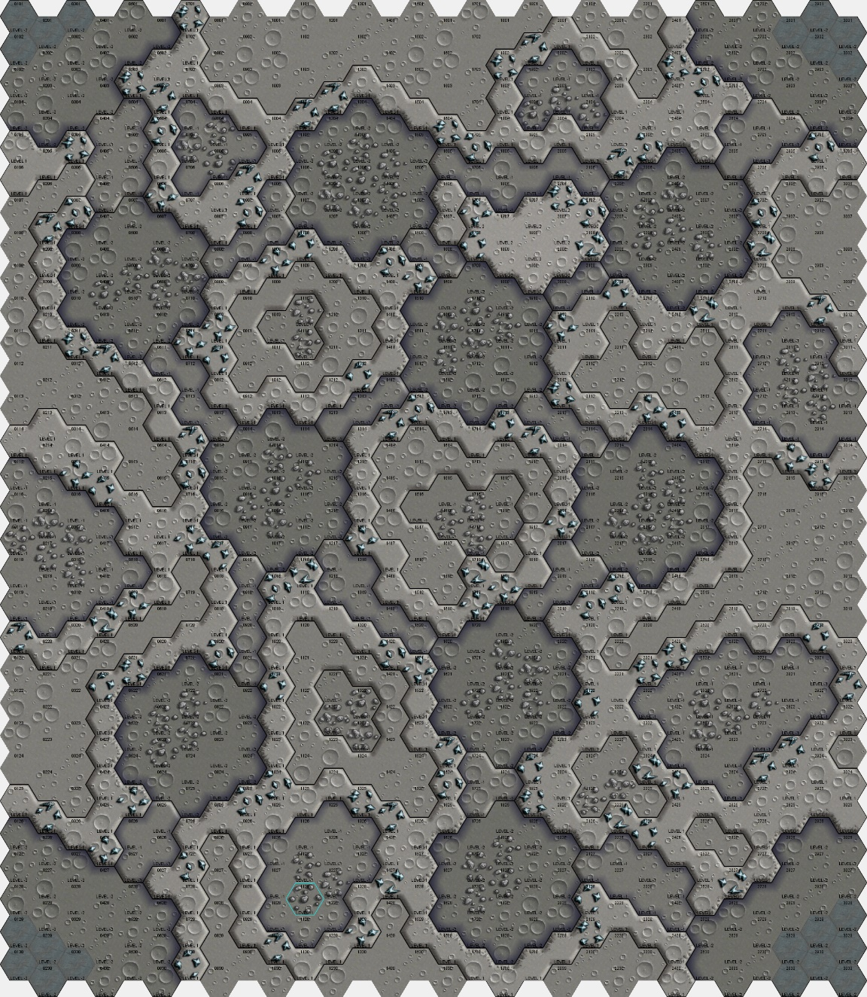

## ‘Planetary Conditions’ to use:

Temperature: 127*C

Atmosphere: None

Gravity: 0.5G

## Starting Locations:

Players should start on the pavement locations in the map’s corners.

## Special Rules:

Space suits: All mechwarriors competing on the moon are required to fight in space suits to prevent environmental death. A pilot who is forced to eject or who has their cockpit’s life support destroyed should be treated as having 5 hits for their injury rolls.

# Map 11 – 30x30 – Independent – Mudpit Murder

## Background:

The mudpit is an arena which ‘does what it says on the tin’ – a deep former quarry, filled with sandy soil and permanently sprayed with water from high pressure hoses to keep the ground soaking wet.

The water collects in the base of the arena, creating a small lake, whilst the slippery ground is treacherous for any ‘mech daring to try and use its speed to close with an opponent.

## Map Image:

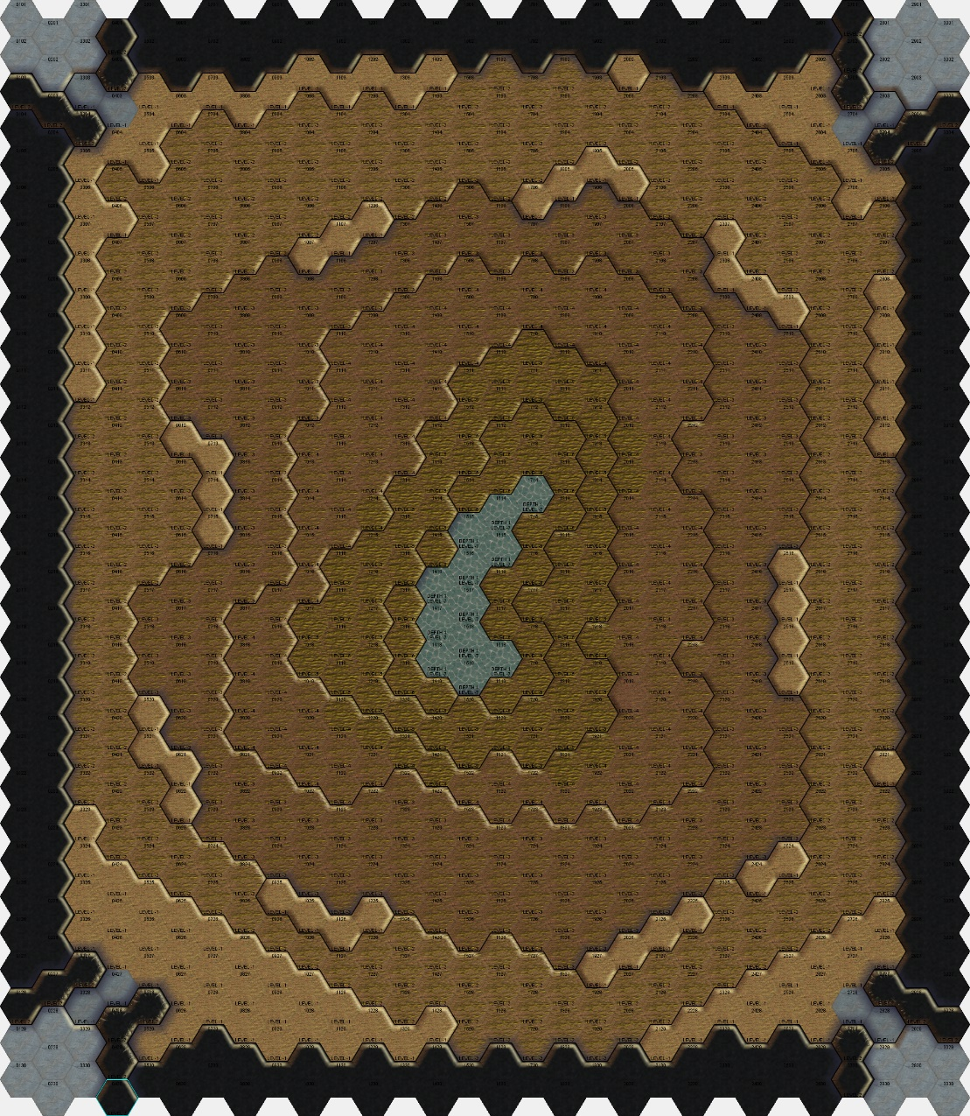

## ‘Planetary Conditions’ to use:

The MegaMek defaults should be used. No weather is in play.

## Starting Locations:

Players should start on the pavement areas in the corner of the map.

## Special Rules:

None.

# Map 12 – 40x20 – Steiner – Colosseum Alternate Config. A

## Background:

The Steiner Colosseum is the premier arena on Solaris; the location where all competitors dream of taking the stage before a live audience of thousands and a broadcast audience of millions, if not billions across the Inner Sphere. The Colosseum is one of the few arenas on Solaris to allow a live audience thanks to its sophisticated disruption field to protect the crowd.

The alternative configuration for the arena sees the larger pillars retracted, and a smaller ‘mini-arena’ created in the centre to focus the fighting.

## Map Image:

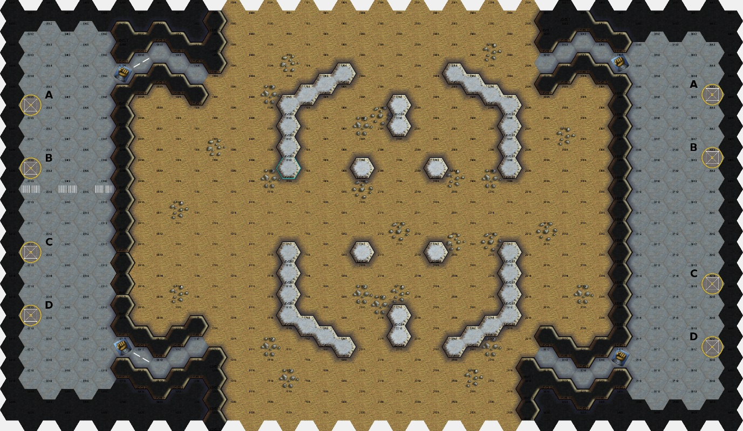

## ‘Planetary Conditions’ to use:

The MegaMek defaults should be used. No weather is in play.

## Starting Locations:

Players may start on the north and south board edges, or may start play in the ‘mech bays in the east and west. Hostile players may not share a ‘mech bay.

## Special Rules:

The impassable hexes around the ‘mech bays do not block line of sight in MegaMek. Players should treat these impassable hexes as line of sight blocking and not fire at opponents through the hexes.